Shabbos Stories For
Yom tov shavuos 5786
Volume 17, Issue 37 6-7 Sivan/May 22-23, 2026
Printed L’illuy nishmas Nechama bas R’ Noach, a”h
Kiddush Hashem
Has No Set Amount
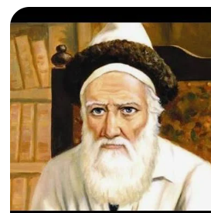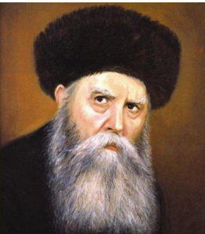
The Tzemach Tzedek and the Riyatz

The Riyatz of Lubavitch (Rabbi Yosef Yitzchak Schneersohn, 1880-1950) zy”a related that when his grandfather, the Tzemach Tzedek (Rabbi Menachem Mendel Schneersohn, 1789-1866) zy”a was the Rebbe, the Maskilim grew more daring and sought ways to obstruct Yidden from doing mitzvos. To this end, they worked together with Czar Nikolai of Russia to enact anti-religious decrees.
In the year 5603 (1843), a committee was created in the capital city of St. Petersburg to regulate Jewish education. Numerous Gedolei Yisroel were summoned to testify before the committee, including the Tzemach Tzedek, Rav Itzele of Volozhin, and others, who all worked tirelessly to annul this harsh decree.
The Tzemach Tzedek spoke very sharply, saying that the government had no right to meddle into religious affairs. This angered the head of the committee, who wanted to punish him. However, the Tzemach Tzedek was unperturbed, and he continued his battle. Rav Itzele asked him how he had the courage to act like this. Wasn’t he afraid that he was putting himself in danger? And since it is forbidden to endanger oneself, wasn’t he afraid that he would be punished for this in Olam Haba (the World to Come)?
The Rebbe replied, “If Klal Yisroel doesn’t have Olam Hazeh, what do I need Olam Haba for? Furthermore, the Torah commands us to make a Kiddush Hashem, and Kiddush Hashem has no limits!”
Reprinted from the Parshas Emor 5786 email of The Way of Emunah: Collected Thoughts on the Weekly Parshah from Rabbi Meir Isamar Rosenbaum

Pausing the Asifah

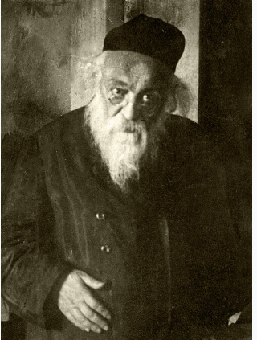

Rav Chaim Soloveitchik (1853-1918) was once traveling by train to attend an asifah convened to address the newly imposed draft decrees. On that same train was a young yeshivah bachur. When he noticed Rav Chaim boarding, he approached and warmly extended his greeting.
“And where are you headed?” Rav Chaim asked.
“I am traveling to Kuvna, the same town as the Rav,” the young man replied.
“And what brings you there?”
With quiet anguish, the bachur answered, “I have been receiving letters from the military demanding that I report for service. It has been devastating. I have tried every possible avenue, but nothing has succeeded. I heard that in this town there is an askan who, if given fifty rubles, can convince a doctor to issue a letter stating that I am unfit to serve in the army.”
Rav Chaim listened attentively, his face reflecting compassion. He told the young man that if he would need any further assistance, he should return to him.
Once he got there, he realized that there was no such person. Instead, he found that if he gave the askan two-hundred rubles, he would get an exemption letter.
He was devastated.
The boy remembered the words of Reb Chaim, so without hesitation, he ran…
He came to the door of the asifah where Reb Chaim was meeting with many other rabbanim and demanded entry. But was declined.
He persisted, explaining that Reb Chaim instructed him. This caused a commotion outside the door, until it reached the attention of the participants.
Reb Chaim immediately instructed that the bachur be admitted.
Once inside, the young man explained that he only could get the discharge if he brought four times the amount that he originally had been told he would need to give.
Without delay, Rav Chaim paused the asifah and turned to the rabbanim and askanim, collecting the necessary funds to secure the bachur’s exemption.
Later, Rav Dovid would recall that many of the participants questioned his father’s decision. Why interrupt a critical gathering — one dealing with matters affecting the entire community — for the sake of a single individual?
Rav Chaim had gotten up, banged his hand on the table, and responded with unwavering tone of voice:
“Saving a single neshamah is saving Klal Yisrael. Protecting the ruchniyus of a single person is no less precious than safeguarding the spiritual welfare of the mass and requires no less effort to have him spared from the danger at hand.”

Reprinted from the Parshas 5786 email of Zichru Toras Moshe

The Power of a Thank-You

Rabbi Frand shares a story that sounds simple, but when you listen carefully, it is overwhelming. A brother and sister were shopping in Monsey before Pesach. They finished, got into the car, ready to leave. The brother suddenly looks up and freezes. Across the street is a rebbi he had years earlier. He tells his sister, “I just want to go say hello and thank him.” He runs across the street and says something simple: “Rebbi, I want you to know I appreciate what you did for me.” A few words, nothing elaborate.
He comes back, then remembers something else he needs and runs into another store. Now the sister is sitting alone, watching what just happened, and thinking. At that moment, she sees her sixth-grade English teacher walking down the street. Not a rebbi, not a mashgiach—just a teacher. And she makes a decision.
She gets out of the car, walks over, and says, “I want you to know something. You changed my life. You taught me how to write. You taught me how to express myself. When I applied to a high-level Beit Yaakov high school, I had to write an essay—and I got in because of what you taught me. My whole path changed because of you.”
The teacher thanks her politely, and they part. End of story—except it wasn’t. A few days later, a letter arrives to the parents. The teacher writes, “I have been teaching for 37 years. Recently, the school asked if I want to return next year, and I told my husband I think I’m done. I don’t feel I relate to the girls anymore. When you begin teaching, you’re close in age. You understand them. But now I’m decades older. I don’t think I connect anymore. We don’t need the income. I had already decided I’m going to retire. I had to give my final answer the next day. And that day… your daughter came over to me and told me I made a difference in her life. And because of that, I decided to continue teaching.”
Think about that. A woman was about to close the chapter of her life’s work, a teacher who had shaped generations, who thought she was no longer relevant, no longer reaching. And in one moment, one girl, one sentence, gave her back her purpose. This is not a nice story. This is techiyat ha’metim in real time.

Reprinted from the Parashat Aharei Mot-Kedoshim email of Shabbat Shalom from Cyberspace.
“Zei Gezunt!”

It is related that Rav Hirsch, the Magid of Voidaslov zy”a (the father of Rav Bunim of Peshischa zy”a) once was in Lublin. He needed to send some money to his family in Voidaslov, so he entered the Chozeh’s of Lublin’s bais medrash and asked the men there, “Who is traveling to Voidaslov?” One of those present at the time was Rav Dovid of Lelov zy”a. He told Rav Hirsch, “I am going back to Lelov. On the way, I can stop in Voidaslov.”
The Magid gave him the money and asked him to drop it off by his house. When Rav Dovid got there, he knocked on the door and handed over the money. On his way out, he blessed the family by saying, “Zei gezunt. (Be healthy.)”
A while later, the Magid returned home to Voidaslov. He arrived very late at night, after his entire family had gone to sleep. The door was locked and they did not hear him knocking. However, he had one daughter who was crippled and could not walk, who slept closest to the door. Eventually, she heard the knocking, stood on her feet and walked over to open the door.
When the Magid saw his daughter walking, he couldn’t believe it. He asked her, “When did this miracle occur? How are you able to walk?”
She told him that when Rav Dovid brought them money, he blessed them to be healthy. Since then, she had been able to walk.

Reprinted from the Parshas Emor 5786 email of The Way of Emunah: Collected Thoughts on the Weekly Parshah from Rabbi Meir Isamar Rosenbaum

Tired and Lost
By Dvora Kiel

Several years ago, a flaw became apparent in the tires on my husband’s car. In England we are fortunate to have an excellent guarantee system, which operates to the customer’s benefit, providing that the customer retains the receipt of purchase to prove when the item was bought.
In our case the guarantee covered not only flat tires but all forms of wear and tear for eighteen months. I am blessed with a super-organized nature, and I was sure I would have no trouble finding the receipt for the tires filed away neatly in its place. I duly searched for it, but couldn’t find it. Obviously, it had never been filed.
The next thing to do was, naturally, to ask my husband what he had done with the receipt. I was positive that if he had given it to me, it would have been filed away. It therefore followed that he was at fault, although I didn’t put it quite that way when I asked him. My husband, of course, was just as positive when he delicately told me that he was sure he had given it to me. What else would he have done?
It just so happened that at that very time, someone asked my husband a halachic question. After due deliberation, my husband gave a psak that he was satisfied covered the issue. However, late that night my husband had second thoughts and was afraid he might have overlooked something. He got out of bed and went downstairs to double- and triple-check the sources.
He told me later that he had looked into one sefer, which sent him to another, but he did not feel that it shed any more-light on the subject. Although it was rather late, my husband refused to give up and looked in yet another sefer, which only remotely had anything to do with the topic, or so he thought. Not only did this sefer supply him with the information he was seeking, but between those very pages he was “lucky enough” to find the elusive tire guarantee – which was valid for only a few more days.
The person who asked the halachic question had no inkling of her role in restoring our shalom bayit and in saving us the expense of replacing our tires without a valid guarantee.

Reprinted from the Feldheim Publishers’ “When the Time is Right: Stories of Divine Providence in Everyday Life” by Dvora Keil

What Was the Secret of Rebbe Akiva Eiger’s Greatness

When the Chofetz Chaim, zt”l, visited Yeshivas Toras Chesed in Lodz, Poland, the Rosh Yeshivah, Rav Sender Diskin, zt”l, asked the Chofetz Chaim to speak words of Chizuk and inspiration to the students.
The Chofetz Chaim agreed and said to the Bochrim, “I have always been troubled,” he began, “and I have pondered over this a number of times. The Gaon, Rebbe Akiva Eiger, zt”l, lived not very long ago. Yet, in greatness in Torah, there is no one who can match him. It is obvious from his Teshuvos and Chidushim that his Torah study was Bentched with unusual Siyata D’Shemaya, help from Shamayim.

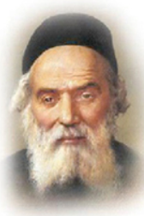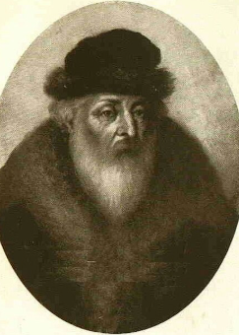
The Chofetz Chaim and RebbeAkiva Eiger

“His questions and explanations are so brilliantly put together that they bring
boundless joy to those who study his words. I have wondered, what was the secret, and the reason, for such Siyata D’Shemaya— which is not found in the generation preceding him, or after him. Why did he merit to become a Gaon among Gaonim? I have thought about this very much, and I have arrived at one conclusion.
During the generation of Rebbe Akiva Eiger, the plague of the Haskalah Movement, the Enlightenment, where secular Jews tried to water down the religion and erode the Torah away from those who adhered to it, began to rise in Klal Yisroel. The damage that they have caused is devastating, and it has destroyed the lives of many of our fellow Yidden. The Shuls were emptied, and Yeshivos were closed due to lack of attendance, as anyone who learned Torah was labeled a primitive parasite. The Torah was cast aside to a corner.
It was specifically in this generation, when the study of Torah had waned so miserably, that Rebbe Akiva Eiger rose to prominence. Every generation is allotted a certain amount of Siyata D’Shemaya, and he was there to take extra portions, because sadly, no one else came forward.”
The Chofetz Chaim concluded, “Today, it is not much different. We are living in a time when those who hate the Torah will do anything to prevent a Ben Torah from achieving his goals. The Siyata D’Shemaya out there is very abundant and available to whoever seizes the opportunity, and he will be Bentched by Hashem with tremendous success in Torah. We just have to take advantage of this great opportunity!”
Reprinted from the Parshas Emor 5786 email of Rabbi Yehuda Winzelberg’s Torah U’Tefilah.

Tell the Police the Truth

There are times when telling "the whole truth" to government officials can be challenging. However, someone who truly values honesty, like Rav Noigershel—one of the leading teachers of Jewish ethics—can find the strength to avoid rationalizing dishonesty.
On one occasion, Rav Noigershel was being driven to Jerusalem by a driver who had spent the previous night caring for his father at the hospital and hadn't slept at all. As they entered Jerusalem, the exhausted driver nodded off, causing their car to skid off the road and down a cliff. Miraculously, both men emerged unharmed.
Police arrived shortly after the accident. Rav Noigershel encouraged his driver to explain exactly what had happened, despite the risks. He felt that having experienced such a miracle, he owed it to Hashem to tell the truth...

Reprinted from the Parshas Tazria-Metzora 5786 email of Sefas Tamim as written by Rabbi Yair Hoffman.
Rating One’s Quality of Life
From the Desk of Yerachmiel Tilles

It is not easy to find an English lecturer in Bnei Brak and it is harder yet to find a good one. Rabbi Aharon Levin is both. Once, he totally wowed the students of Yeshivat HaKotel in Jerusalem’s Old City with his presentation, and then again at the end of his captivating talk when he threw in the following personal story.
Shimon, a student of Sephardic ancestry, learned together with him in the prestigious Slabodka Yeshiva in Bnei Brak. Years later, Shimon was diagnosed with cancer, and Rabbi Elimelech Firer, the renowned medical referral expert, felt that his best chance of recovery would be at the Mayo Clinic in Minnesota. Shimon turned to his old friend and asked if he would accompany him to Mayo to serve as a translator.

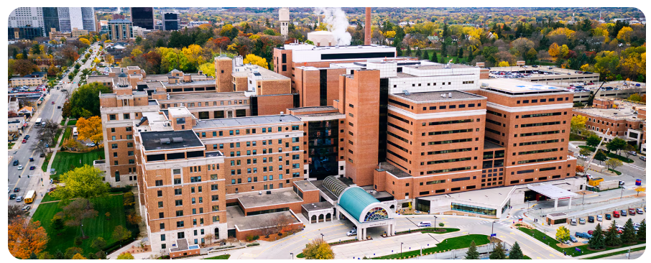
The Mayo Clinic in Rochester, Minnesota

[Mayo is such a world-class medical center that among its teams of everything-medical are also translators of every language, but they are not always available, and one who is in pain does not wish to wait hours to explain how they are suffering.] When you are requested a favor of this magnitude and under such circumstances, there really aren’t a variety of options, so off the two flew to the Mayo Clinic in July 2006. The Mayo Clinic, and the city of Rochester, Minnesota, in which it is located, is a world away in terms of an environment where Torah scholars would feel at home.

One evening, the loneliness of Shimon and Rabbi Aharon somewhat dissipated when they were invited for supper to the home of Mayo’s sole Orthodox physician, Dr. Axel Pflueger. On that occasion Dr. Pflueger related the following incident.
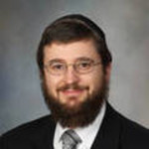
Dr. Axel Pflueger

One day while doing his rounds in Mayo, he saw written at the foot of the bed – and unable to be viewed by the bed’s paraplegic occupant – “Because of Bob’s poor quality of life, his social worker should encourage the family to declare DNR (Do Not Resuscitate) and medications should also not be administered.” Dr Pflueger was appalled at the audacity of the doctor who penned this note, one who was clearly endowed with an acute case of ‘Doctor-thinking-he-is-G-d-Syndrome.’ Accordingly, Dr. Pflueger lodged a complaint against the note’s author, Dr. O’Neill, with the Mayo Clinic ethics committee.
Bob (real name) was a 46-year-old who was involved in an automobile accident when he was six. Like most suffering from spinal cord injury, he had increased risk for respiratory tract infections like pneumonia due to the weakened muscles in the chest and abdomen, which cannot breathe robustly or cough. When Bob would contract pneumonia, which he invariably did on a yearly basis, he had no recourse but to travel to Mayo to be healed.
It is not unlikely that many people might conclude that a paraplegic suffering annually from pneumonia and a host of other issues has a very low quality of life. The ethics committee, like everything else at Mayo, is the gold standard. The head of the ethics committee invited Dr. Pflueger and Dr. O’Neill (not his real name) into his office to resolve the complaint.
As is standard, the accuser is given the floor first. Dr. Pflueger began by asking Dr. O’Neill to rate his own quality of life on a scale of 1-10. (At the Mayo Clinic, everything is done on a scale of 1-10. “How is your pain 1-10?; how much relief do you feel 1-10?; describe your immobility 1-10.”)
O’Neill thought for a moment and replied “6-7.” This is not the kind of answer one would expect from a person who has climbed to the highest rung in the medical world, holding a prestigious job at Mayo. Why, 6-7 is barely passing!
Axel Pflueger then turned to the head of the committee, acknowledged to be one of the most celebrated medical ethicists in the world, and inquired, “What precisely are the criteria to determine one’s quality of life?”
The chairman articulated a well-rehearsed impromptu response, “A person, and only that individual, can determine their own quality of life.” To which Pflueger countered, “Then what, if I may ask, is your quality of life 1-10?” The chairman responded with a disappointing 7-8.
Pflueger then proposed that they pose this question to Bob. So, all three traipsed over to Bob’s room. “Hey Bob,” Pflueger asked in the company of his colleagues, “what would you say, on a scale of 1-10, is your quality of life?”
“9-10,” Bob responded without any hesitancy. “And I’ll tell you why. In the morning the sun’s rays shine on my face and neck, radiating soothing warmth. Sometimes when the weather is good, my mother wheels me outside on my gurney and I am able to smell the perfume of the flowers and hear the singsong of the birds…”
Suddenly Bob got lost in his contemplations. “I am going to have to change my answer,” the supine speaker corrected himself. “I am definitely a full-fledged 10.” With a nostalgic appearance, he reminisced, “Sometimes my mother makes me oatmeal, and because of my condition the only oatmeal I can eat, like all other foods, is a watery gruel. Upon occasion she grates apples very finely and throws in cinnamon and the flavor is just out of this world!”
Bob continued to hold forth, justifying his top score, while the two doctors looked at each other in an apotheosis of remorse.

Source: Excerpted and adapted by Yerachmiel Tilles from in article in the Jewish Press, January 20, 2023, by the famous Jewish storyteller and author, Rabbi Hanoch Teller.

Reprinted from the Parshat Emor 5786 email of KabbalaOnline.org, a project of Ascent of Safat in Israel.
Preparing to Forgive
By Rabbi Reuven Semah

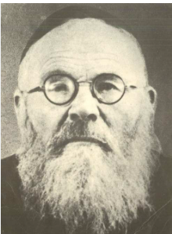

Rabbi Shimon Finkelman shares a story about Rabbi Eliyahu Lopian. Someone approached Rabbi Lopian and said, “I spoke lashon hara about you. I would like to ask for forgiveness (mechilah).”
The Rabbi replied, “How can I tell you that I am forgiving if I haven’t any idea what you said about me. What did you say?”
With his head bowed in shame, the person told Rabbi Lopian what he had said.
“Truthfully,” said the Rav, “I am shocked and very hurt that you would say such a thing about me. If I were to tell you now that I am forgiving you, I would not be speaking
the truth.
“Come back to me in two weeks. During these two weeks I will learn a lot of mussar, and work on myself so that I can find it in my heart to truly forgive you.”
Two weeks later, the man returned to Rav Lopian, who told him that he was now ready to forgive him with a full heart. Rabbi Reuven Semah

Reprinted from the Parashat Aharei Mot-Kedoshim email of Shabbat Shalom from Cyberspace.
Declared Dead After an Accident: Then His Wife Spoke
By Moriah Luz

Doctors had given up hope. Then his wife refused to let go. Discover a powerful story of survival, faith, and the strength to rebuild a life.

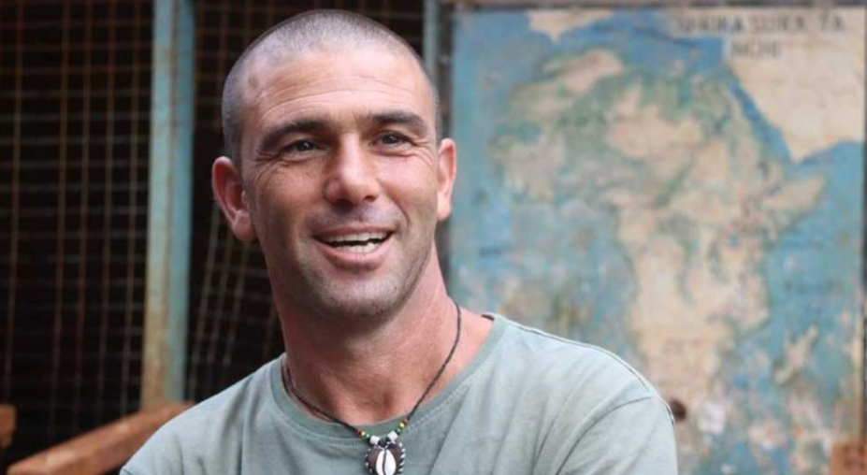
Shmulik Chen after the car crash accident that almost took his life.

The screech of brakes was the last sound Shmulik Chen heard before he lost consciousness. He has no memory of the crash itself, when a semi-trailer truck ran over his pickup and completely crushed it. But that moment, when he nearly lost his life, changed everything.
“You’re Not Leaving Me Alone”
That morning, Shmulik, 52, was driving home from a work trip to Tel Aviv, heading back to Kfar Adumim near Jerusalem. Due to memory loss, he cannot explain exactly what happened, but he likely missed his turn and found himself near the Ashdod Interchange.
“I pulled over to turn around,” he recalls. “A semi-trailer behind me drove up onto my pickup at an angle and then came off. The entire car was crushed. The only part left intact was the driver’s area. They found me bent over, my head between my legs.”
He was pulled from the wreck unconscious and in critical condition. “I had a severe head injury. I was clinically dead. They were already speaking to my parents about organ donations.”
At that point, his wife had not yet been told.
Her father called her calmly and asked her to drop off the children and wait for him to take her to the hospital. On the way, she heard a report on the radio about a critically injured man in a serious accident.
“She asked her father, ‘It’s Shmulik, right?’”
When she arrived at the hospital, four hours after the crash, Shmulik was still clinically dead. The family was called in to say goodbye.
“They told me that my wife came in, grabbed me by the shoulders, and shouted, ‘You’re not leaving me alone.’”
For a brief moment, he opened his eyes, then closed them again.
The family, stunned, begged her to shout once more.
“She shouted again. This time, I opened my eyes and started speaking as if nothing had happened.”
Even the medical team could hardly believe it. A police officer who had been at the scene later visited him in the hospital.
“He looked at me and said, ‘They pulled you out of the car like a dead cat.’”
A Life Turned Upside Down
Before the crash, Shmulik ran a successful construction business with employees and subcontractors. It had been his focus for 15 years.
In an instant, everything changed.
He spent five months in the hospital and in rehabilitation, followed by five more years of intensive day rehab, relearning basic skills. He was forced to shut down his business, sell an apartment, and use up his savings. The family entered a difficult financial period.
The physical and emotional challenges were overwhelming. He suffered from severe headaches and could not tolerate noise. Even small sounds would cause intense pressure and stress.
“I would come home, hear the kids making noise, and lose control,” he shares honestly. “My wife would sometimes take the children out when I got home. I’m not an angry person, but the pain was unbearable.”

Moments of Kindness Along the Way
Even during those difficult years, there were moments that felt like small miracles.
At one point, Shmulik needed 3,000 shekels, a large amount for him at the time. Unexpectedly, he received a letter saying he was entitled to that exact sum. When he went to clarify, he was told that a contractor had charged the local council less than expected and asked that the difference be given to him.
Shortly after, that same contractor offered him a job suited to his condition, driving workers to and from job sites. It gave him both purpose and financial relief.
Another turning point came when doctors prepared him for brain surgery due to swelling. Just before the procedure, a final test revealed something surprising.
“There’s no need to operate,” the doctor said. “He has natural drainage.”
Because of the way his injury had altered the structure of his head, the pressure was being relieved naturally. He avoided surgery entirely.
“After everything I went through,” he says, “I didn’t need a single operation.”

Searching for Answers
During his long recovery, Shmulik would spend hours sitting on the hills near his home, looking at the sky and searching for meaning.
A local rabbi once approached him and asked what he was doing.
“I told him, ‘I’m looking for answers.’”
The rabbi invited him to join a daily Torah class.
“If you want answers,” he said, “come learn with me.”
Shmulik did not grow up religious, but he decided to try. The learning brought him calm and clarity. Slowly, it reshaped his outlook on life.
“I realized I’m not alone,” he says. “The world is much deeper than I thought.”
Today, he and his wife live a religious lifestyle, along with most of their children.
“I feel like I have a direct connection with Hashem,” he says. “I see Him in everything.”
Giving Back and Finding Purpose
His journey also led him to explore alternative medicine, which helped ease his pain. He later began volunteering, treating cancer patients to help relieve their suffering.
“I discovered something powerful,” he says. “When you give, you receive much more.”
That realization changed everything.
He began working in an educational institution, eventually becoming a logistics manager for a large network with multiple campuses. At the same time, his volunteer work expanded. He joined missions to Africa, helped rescue Israelis from Ukraine, and assisted in disaster relief efforts.
Recently, he was chosen to light a torch representing action and mutual responsibility in his community’s Independence Day ceremony.

A New Understanding of Family
Before the accident, Shmulik believed that financial stability was the foundation of everything.
“I thought money held a family together,” he admits. “I focused on earning and did not invest enough in my family.”
After the crash, his perspective changed completely.
“Hashem showed me that you may not have money, but you have your family.”
The transformation took time, but today, he says, “My wife and I are truly close. Family is at the center of my life.”
"Do not let fear control your life"

What Truly Matters
Looking back, Shmulik does not wish to undo what happened.
“Yes, I’m grateful,” he says. “The peace I have today is far greater than anything I had before.”
His biggest lesson?
“Do not let fear control your life. If something matters, do it.”

Reprinted from the current website of Hidabroot.com
******************************************************************
Celebrating Shavuos in 19th Century Frankfurt, Germany
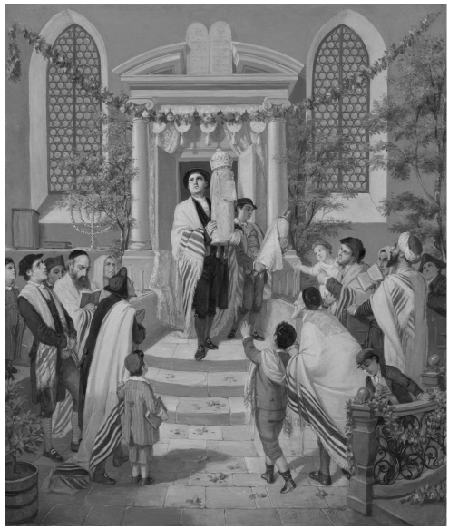
1880 oil on canvas by Moritz Daniel Oppenheimer showing Jewish congregants in Frankfurt, Germany celebrating Shavuos in a synagogue.

